Older Adult & Elderly Services in San Mateo County

Aging and Adult Services – TIES Line
24-hour hotline 1-800-675-8437
*report abuse
*can provide # to families for older adult/elderly community resources
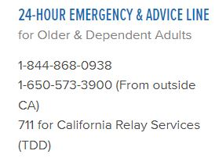



Concerns with abuse/neglect in a nursing home/board and care/assisted living facility? Can the San Mateo County Ombudsman at 650-780-5707


Institute on Aging

Friendship Line
800-971-0016
- Crisis intervention and referrals
- Well-being telephone check-ins
- Follow-up home visits for supportive counseling and psychotherapy
- Group and individual grief counseling
- Specialized counseling and bereavement support for people who have experienced traumatic loss to suicide or sudden death
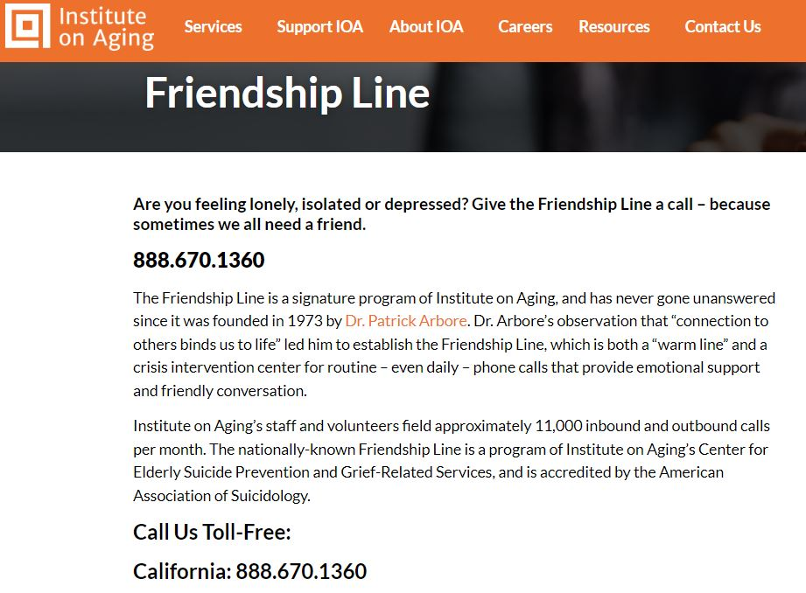

Legal Aid Society of San Mateo County Senior Advocates Program
650-558-0915
Offer legal advice, advocacy, and representation in following areas:
- Government benefits including Social Security, SSI, Medi-Cal, CalFresh, and Cash Assistance Program for Immigrants (CAP)
- Elder Abuse
- Consumer law and debt collection
- Simple wills
- Guardianships for seniors caring for young children
- Advance health care directives, so that individuals can appoint caregivers with power of attorney to make health care decisions on their behalf


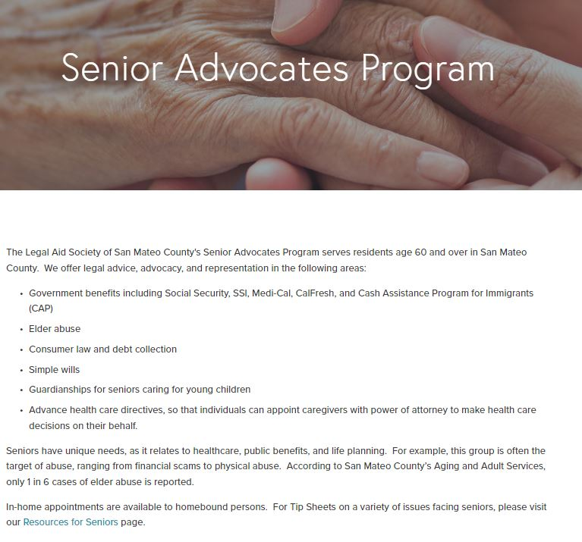

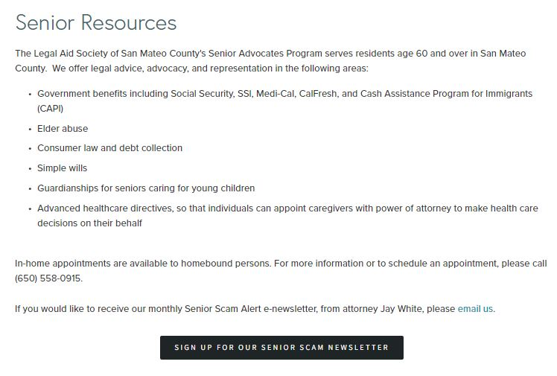

Peninsula Family Service Resource Line (PFS)
650-780-7542
Available M-F 7:30 am – 4 pm
- Housing Assistance
- Food Services
- Transportation
- COVID Information & Testing
- Referral to a Peer Counselor
- Information about Community Groups and Virtual Gatherings
- Services and Resources in Other Languages


Additional Older Adult Services - Peninsula Family Service
650-403-4300
- Peer Counseling
- Fair Oaks Adult Activity Center
- Help@Hand – Technology Education and Workshops
- You Talk, We Listen – Counseling
- 650-403-4300 ext 4389 for more information
- $15 co-pay per visit

San Mateo Senior Center
650-522-7490

Meals on Wheels
650-323-2022

Self-Help for the Elderly
650-342-0822

City of San Mateo Senior Resources

San Mateo County Senior Resources

Other Institute on Aging Services:

Corio Home Care Support Services
- Assistance with personal care, medication cueing, household tasks, companionship, transportation and errands
- Personalized care for aging adults in the comfort of their own homes
- Licensed, bonded, and insured caregivers are on call 24 hours a day, 7 days a week

CalAIM San Mateo
Support with:
- Finding doctors and getting appointments
- Understanding prescriptions and medications
- Follow -up services after you leave the hospital
- Transportation
- Food security
- Housing navigation and deposits
Eligibility
- Health Plan of San Mateo (HPSM) member
- Have multiple chronic or mental health conditions
- Have visited an ER or hospital multiple times in last 6 months
- Willing to move to a home from a nursing facility
- Are in need of a safe place to live

